|  |  |
| --- | --- |
| Product Name | Applied Degree in Software Engineering (BDSE) |
| Qualification Name | Applied Degree in Software Engineering |
| Product Name |  |
| Module Name (BDSE) |  |

|  |  |
| --- | --- |
| Learner Name | Assessor Name |
| Khaing Lin Htet | Ms. Ayesha Shariff |

|  |  |  |
| --- | --- | --- |
| Date Issued | Completion Date | Submitted On |
| February 3, 2023 | Feb 9, 2023 |  |

|  |  |
| --- | --- |
| Project Title | ABC Learning Center Website |

|  |
| --- |
| **Learner Declaration** |
| I certify that the work submitted for this assignment is my own and research sources are fully acknowledged.        Student Signature                                                    Date:  Submission date |

Diagram of Information Architecture

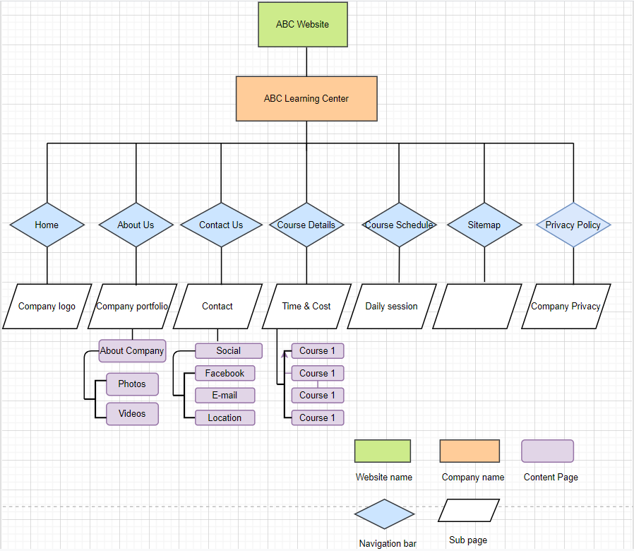

**Diagram of ABC learning center wireframe**

This Page is for the ABC Learning center home page

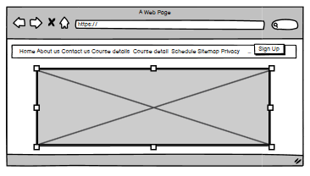

The page is about for the ABC Learning center

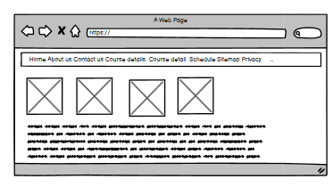

This page is contact to ABC Learning center ;

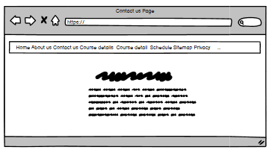

This is for detail of course ;

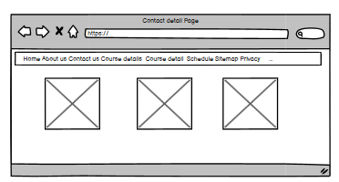

This is about course timetable

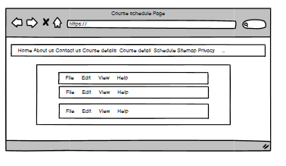

This is for site map page;

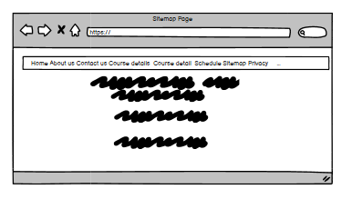

This is for Privacy Police page ;

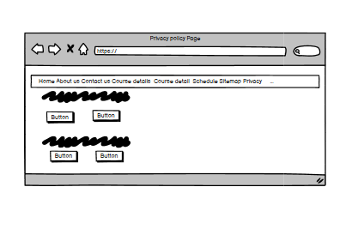

**Storyboard for the ABC learning center**

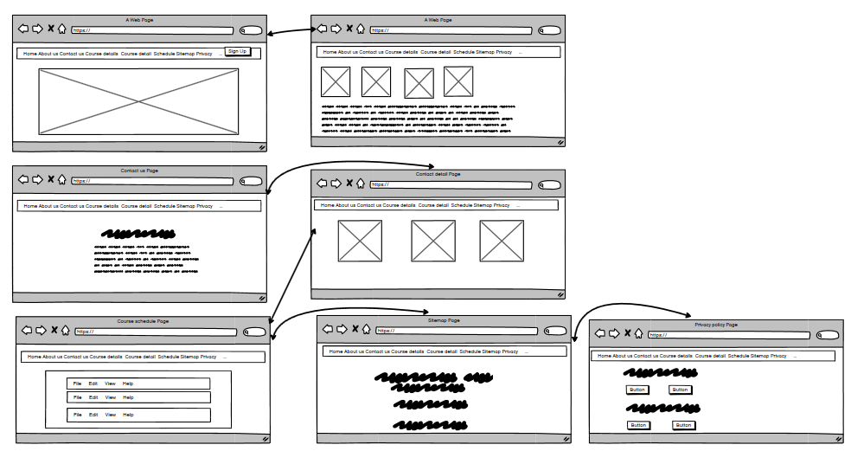

ABC Learning Center Home Page source code;

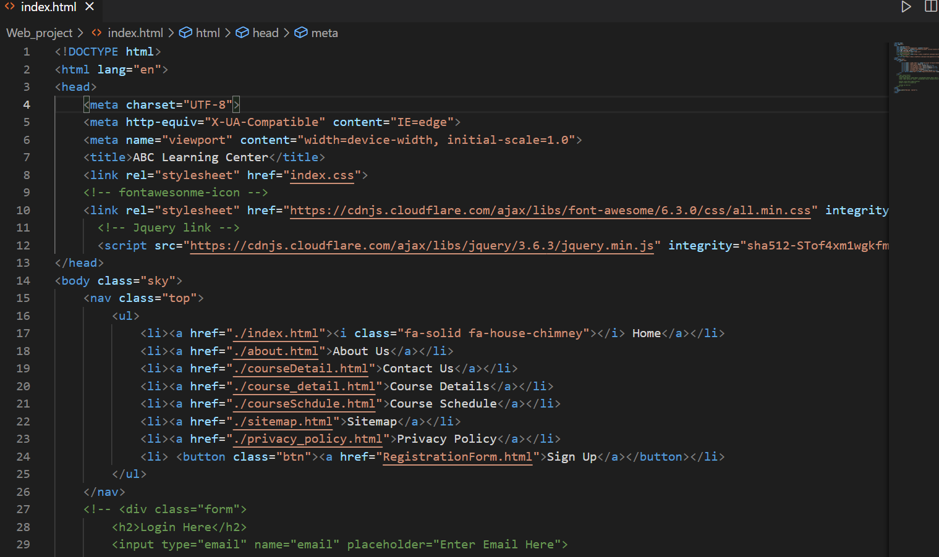

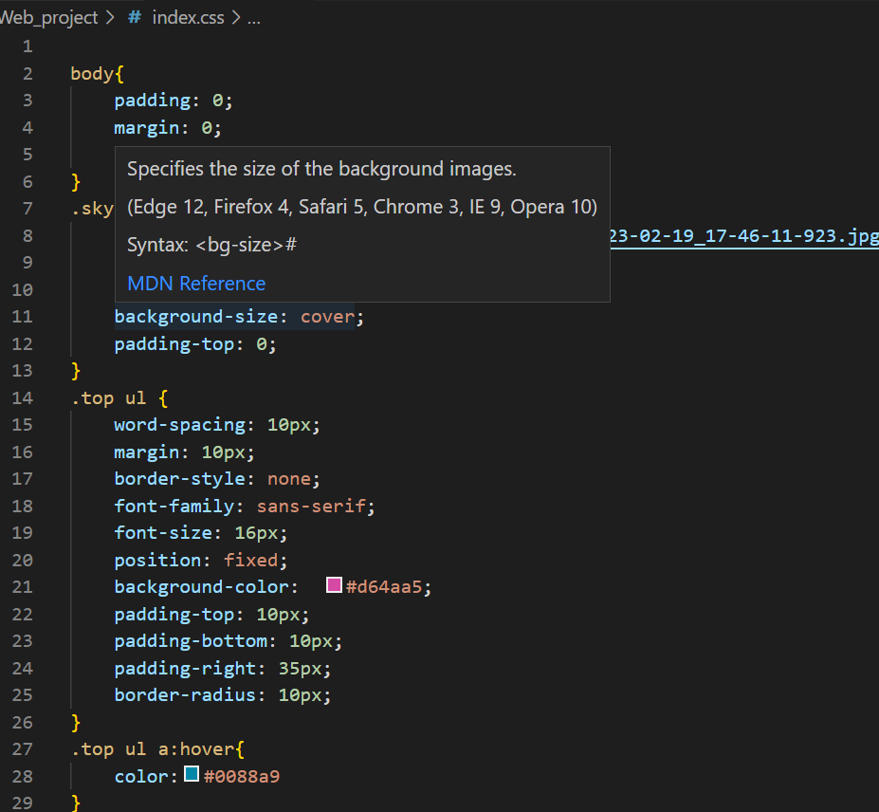

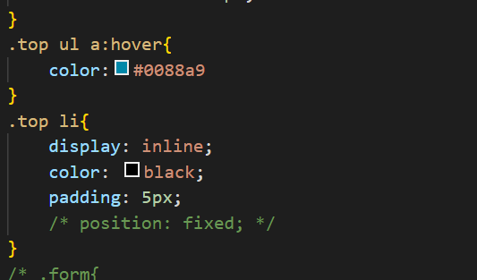

ABC Learning Center Home Page;

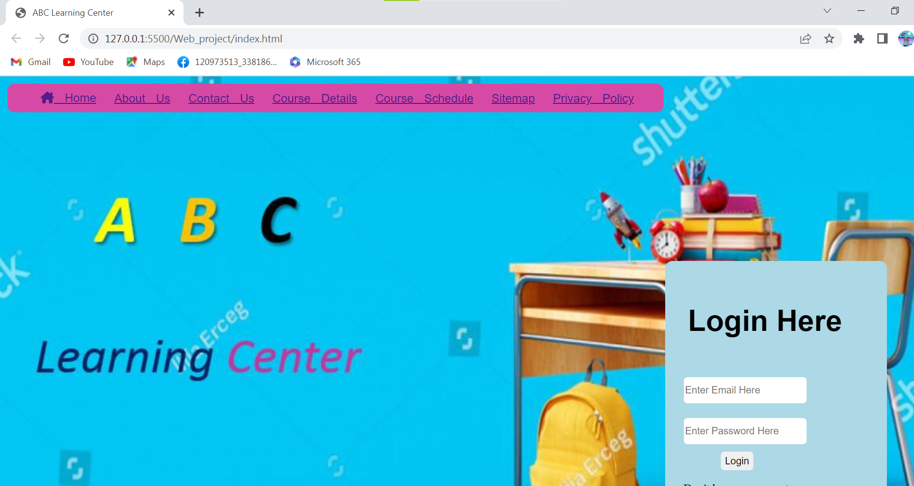

ABC Learning Center About Us page source code;

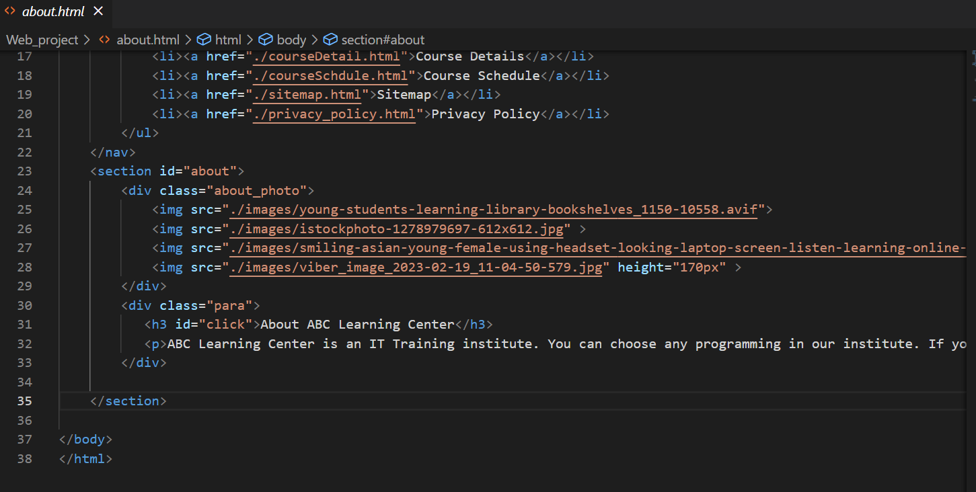

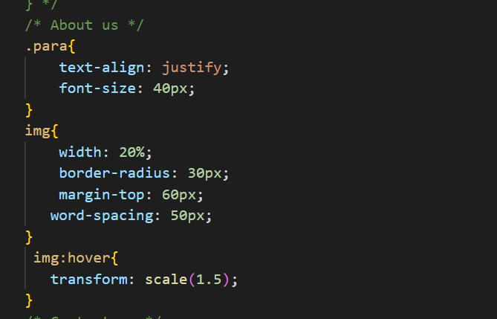

ABC Learning Center About Us page;

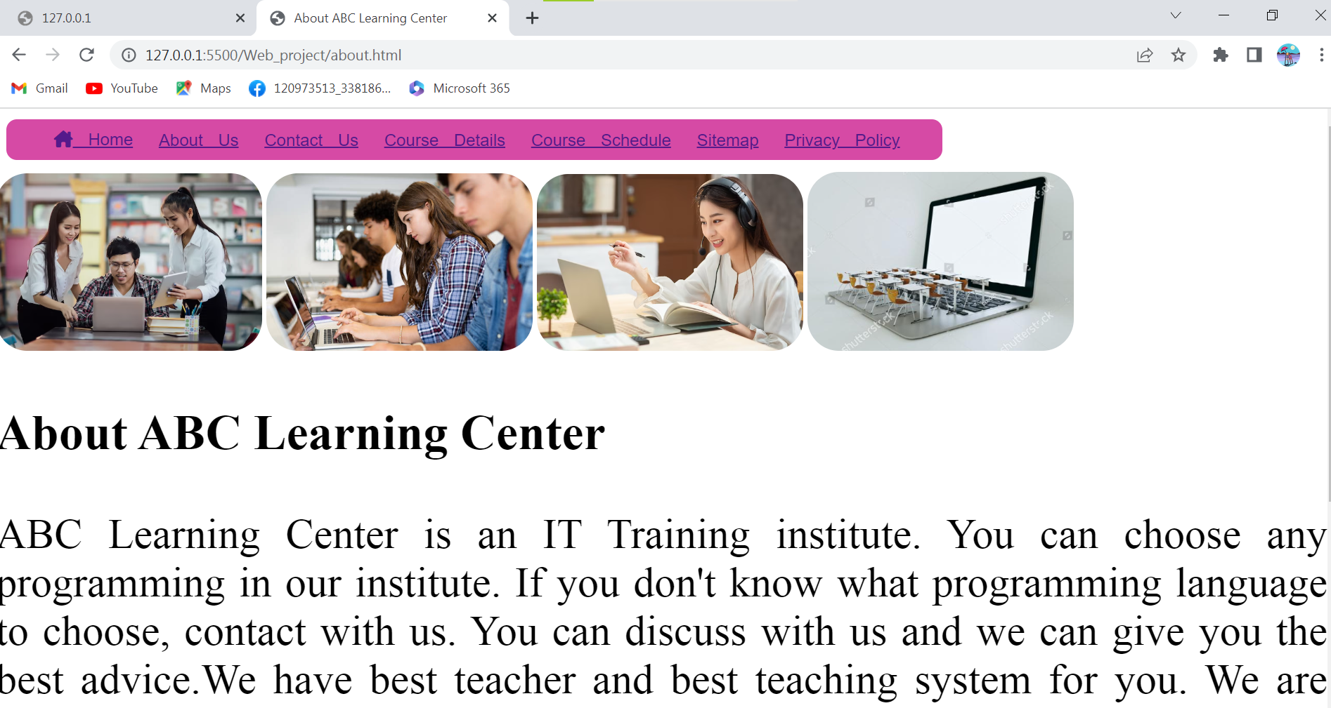

ABC Learning Center contact us page source code

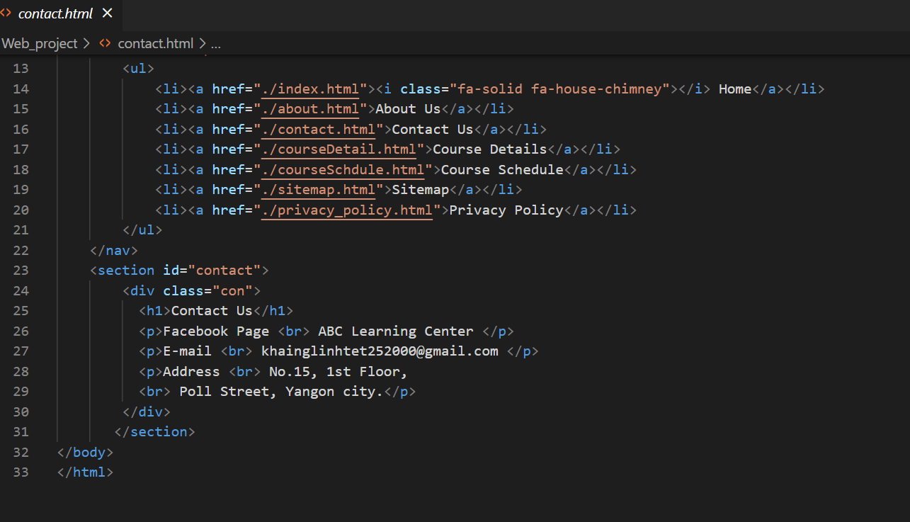

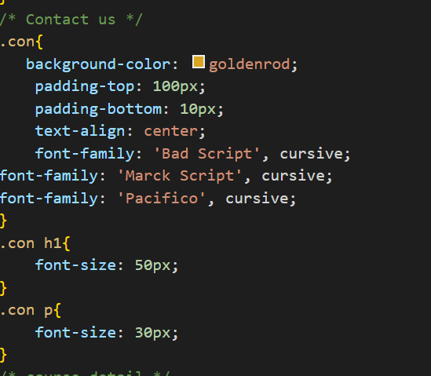

ABC Learning Center contact us page;

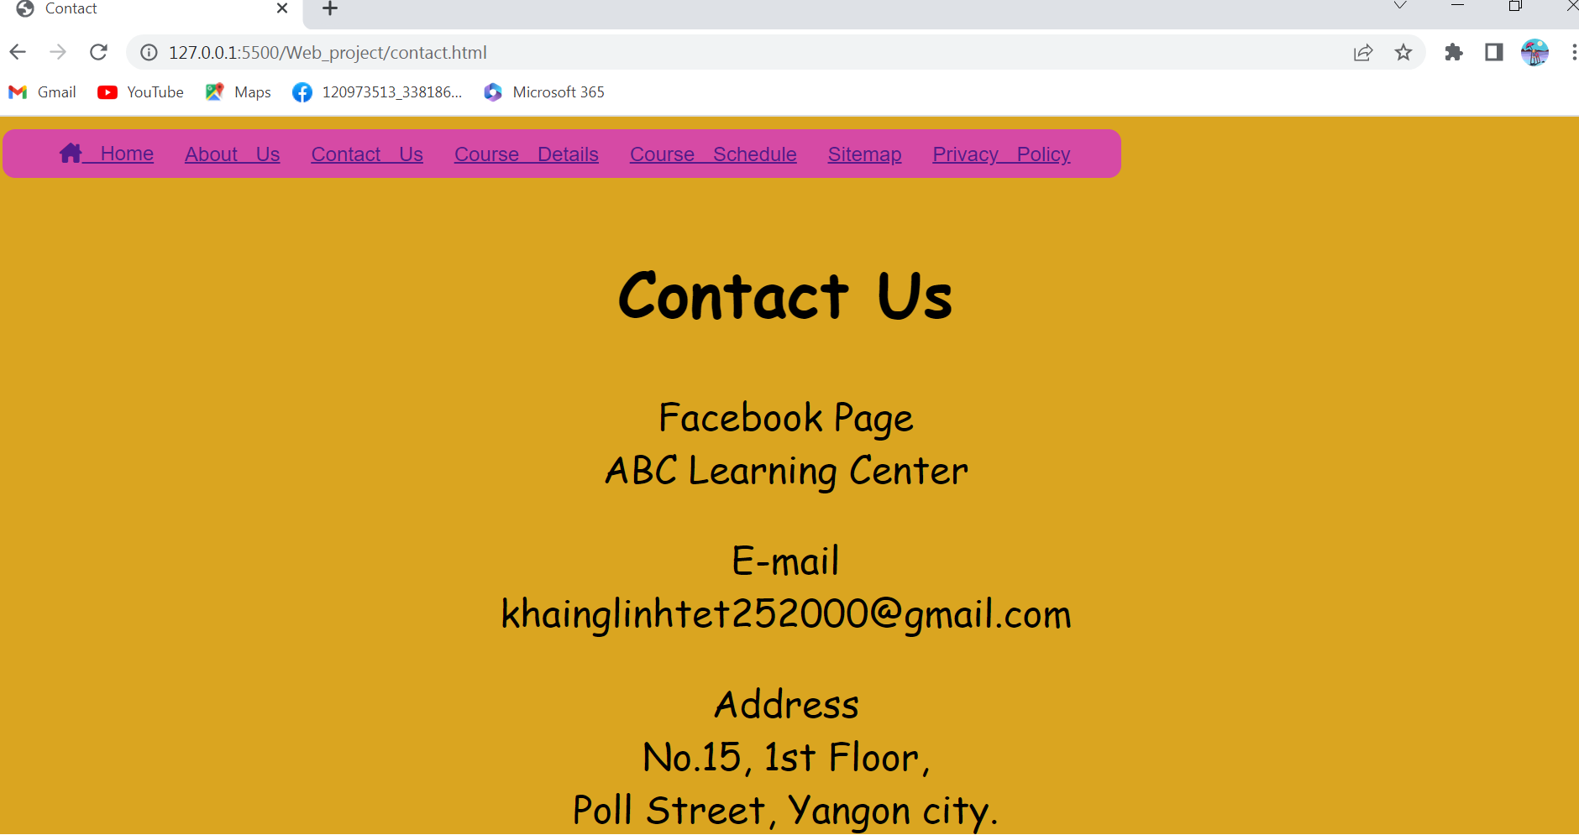

ABC Learning Center course details page source code

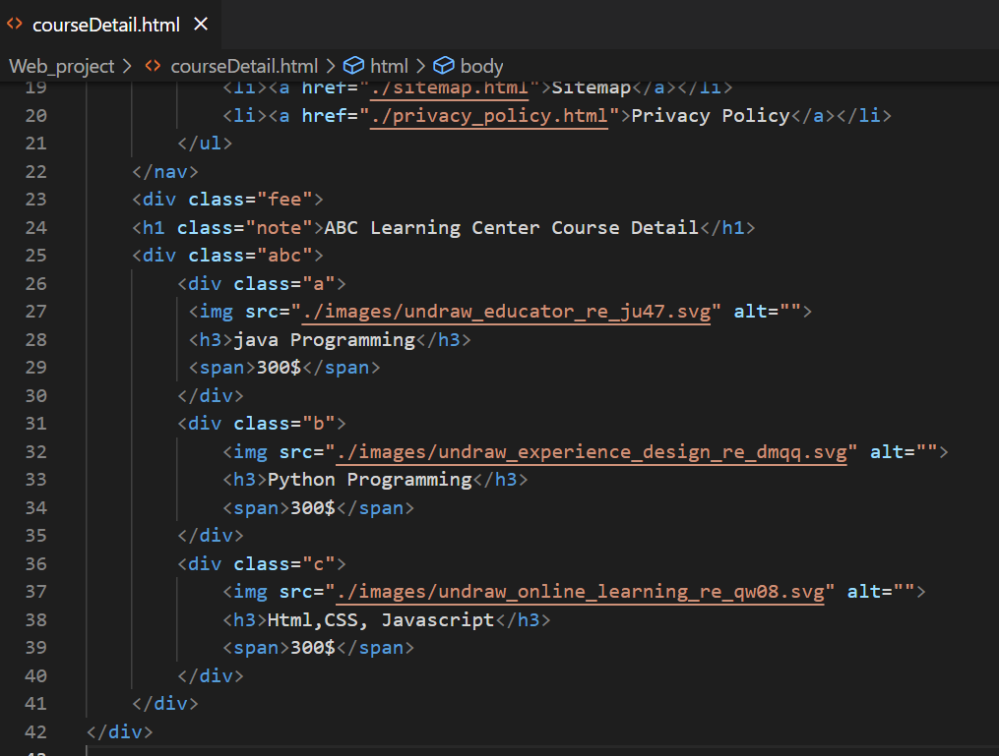

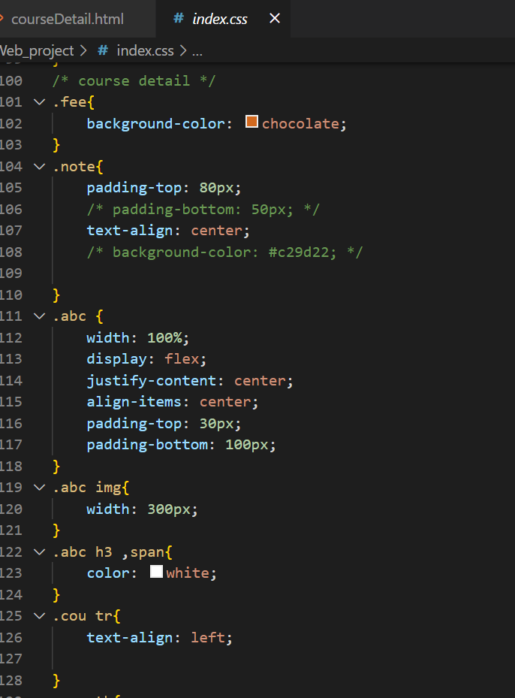

ABC Learning Center course details page;

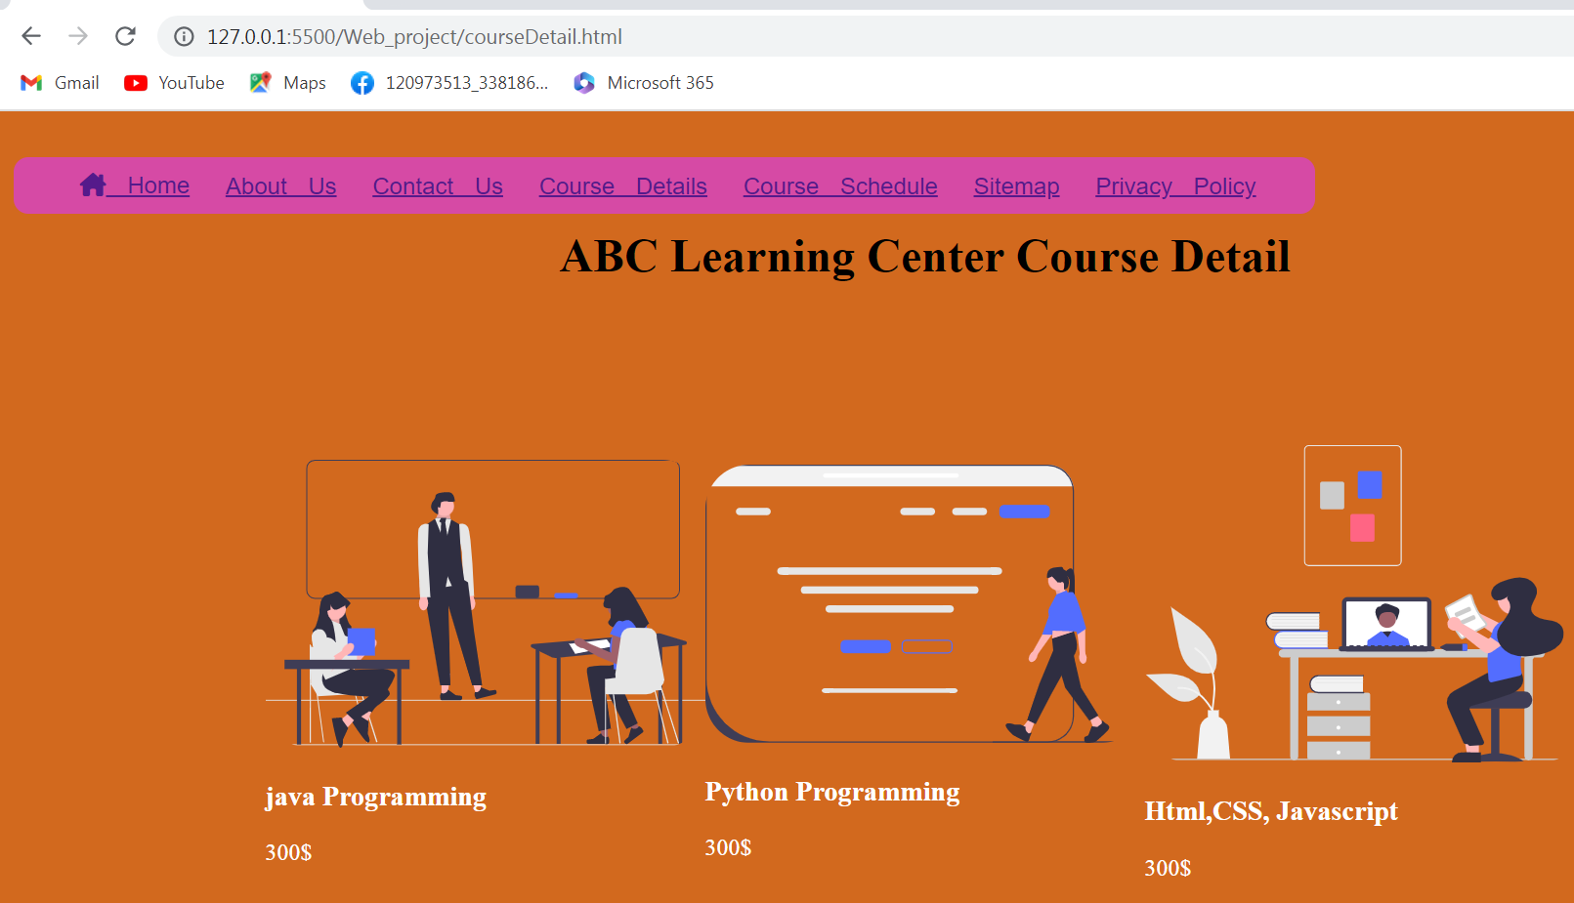

ABC Learning Center course schedule page source code

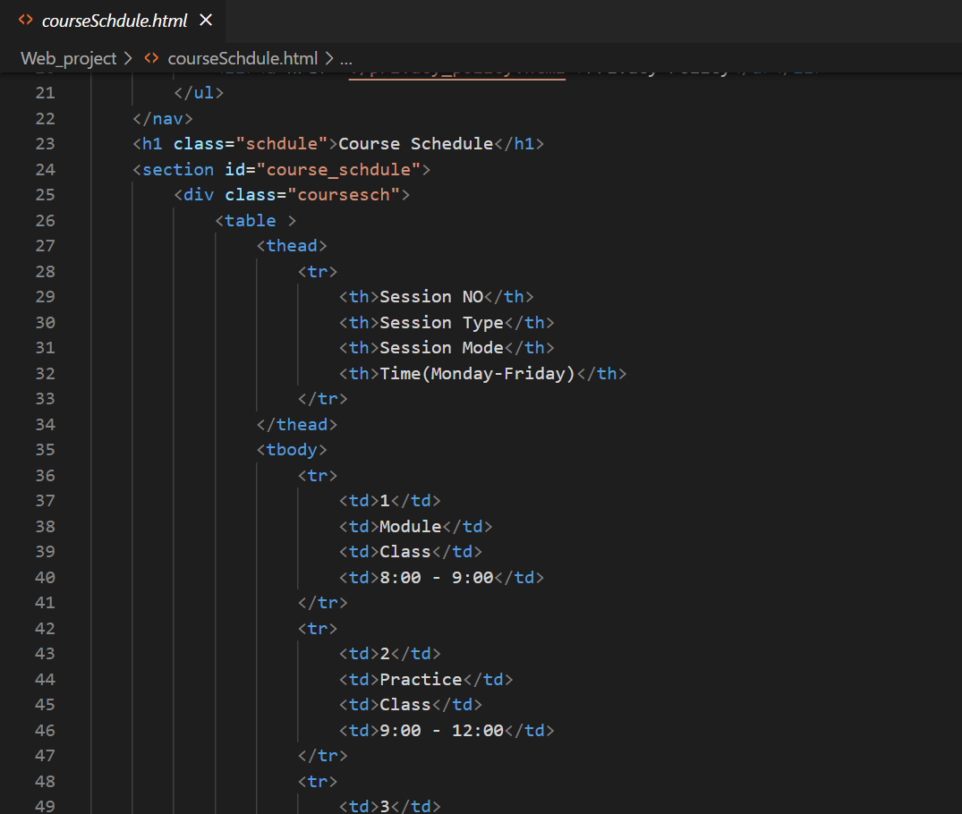

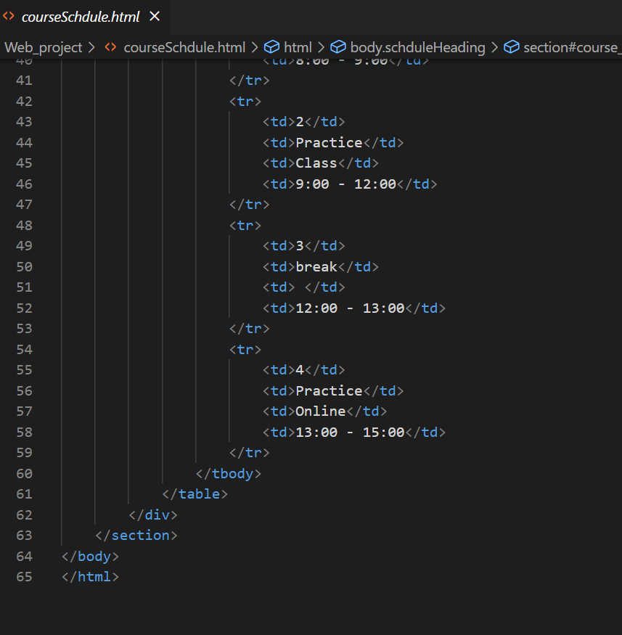

ABC Learning Center course schedule page;

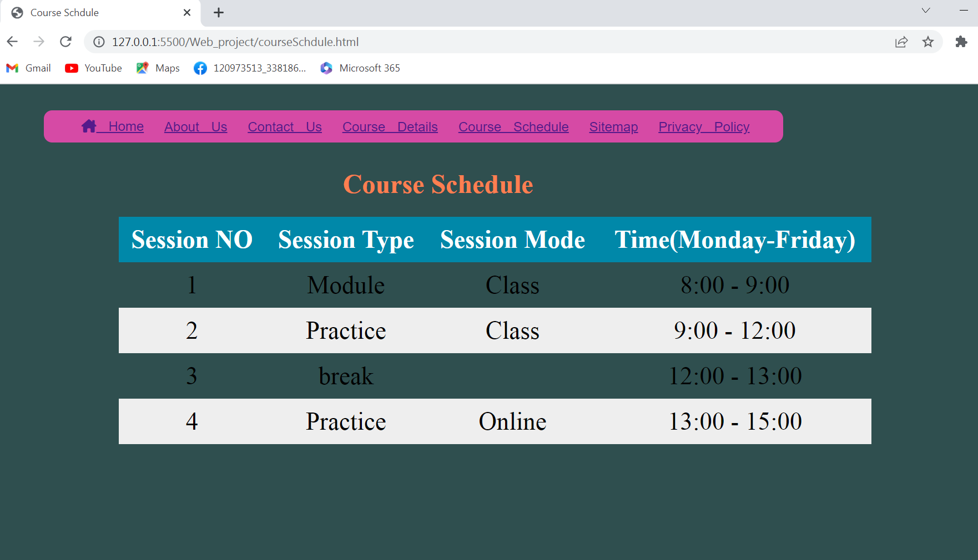

ABC Learning Center sitemap page source code

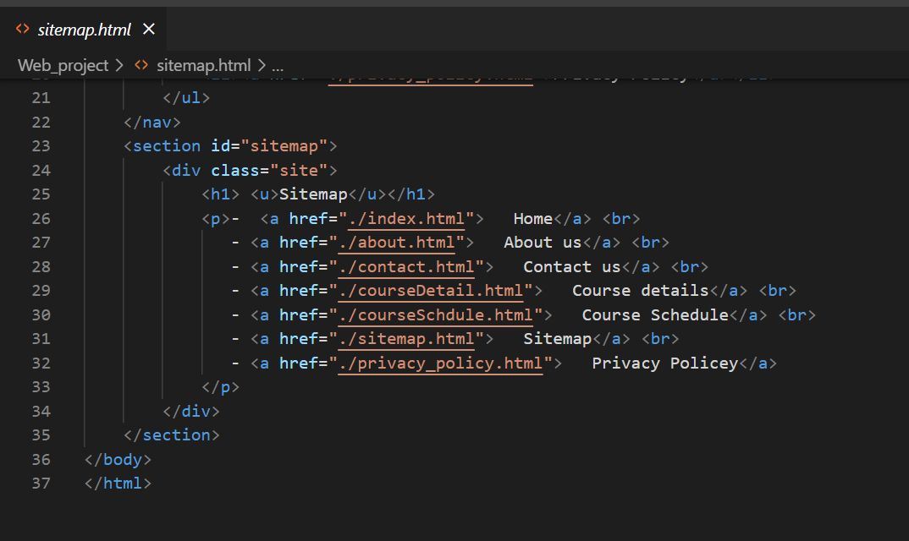

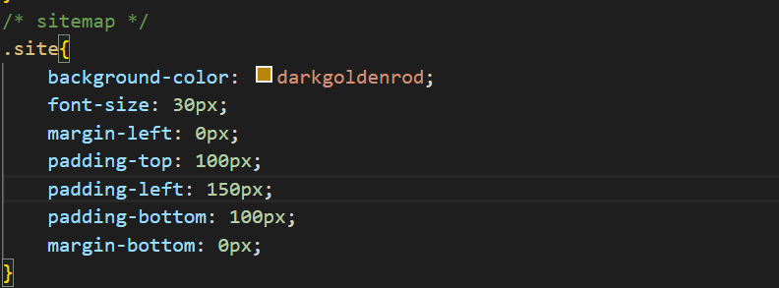

ABC Learning Center sitemap page;

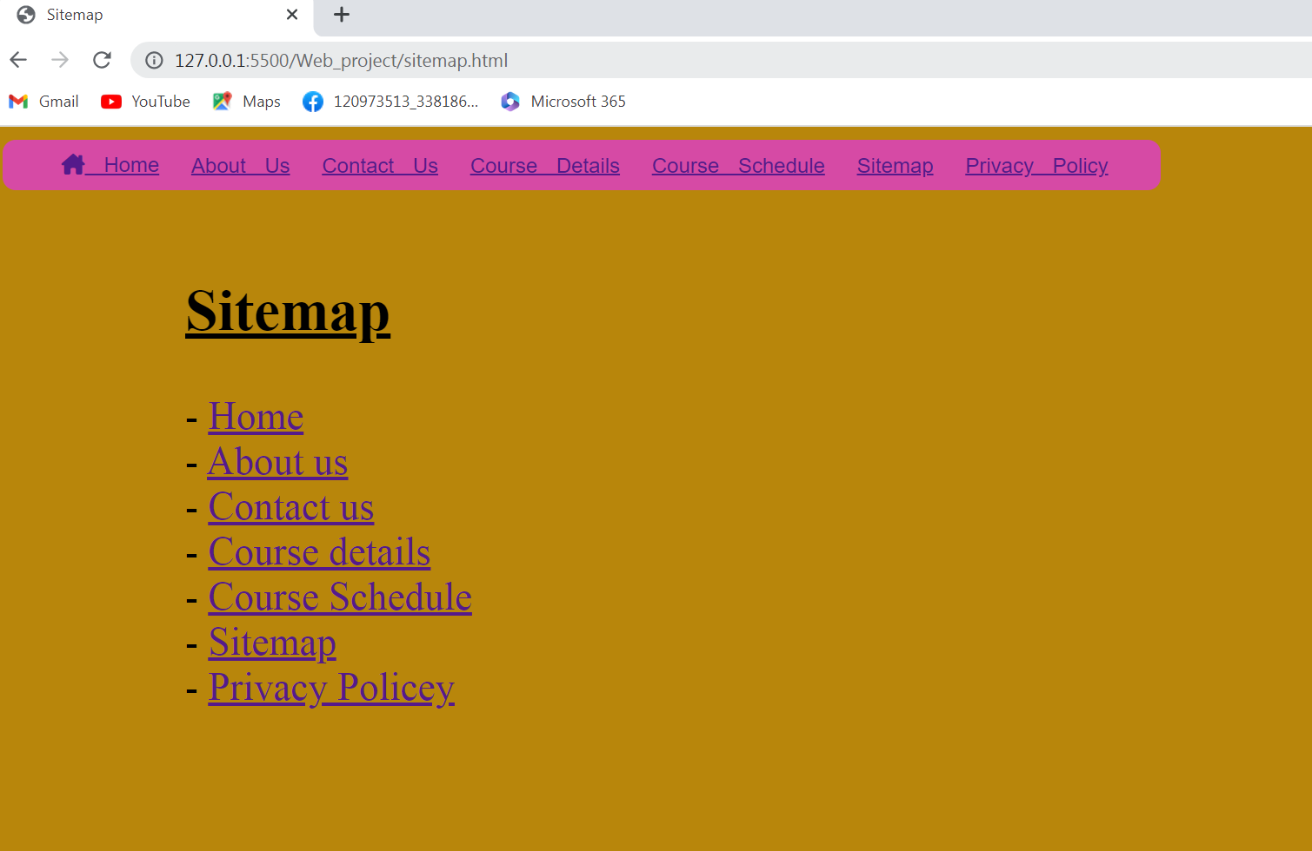

ABC Learning Center privacy center source code

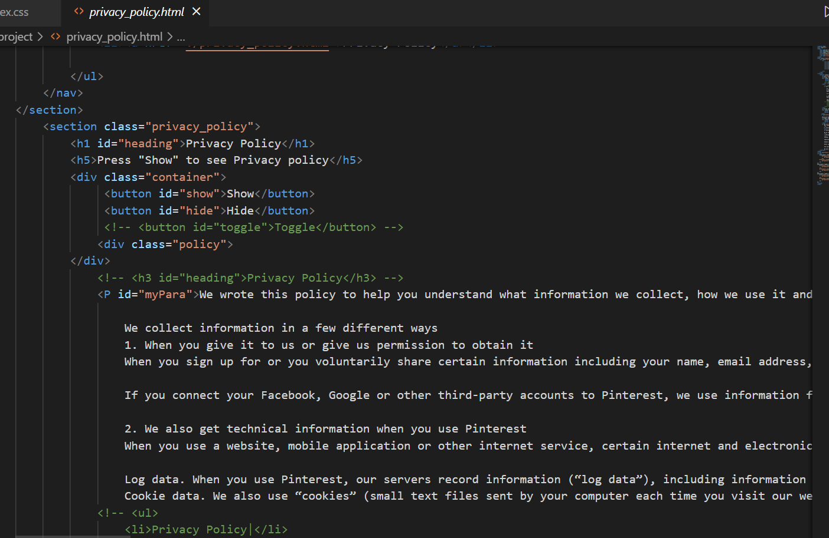

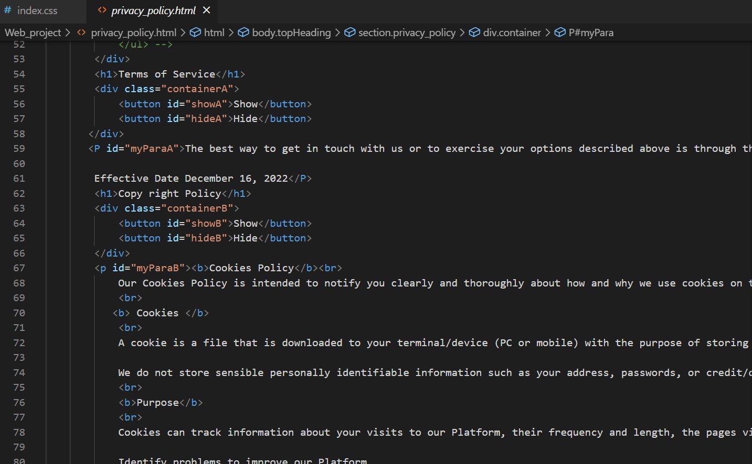

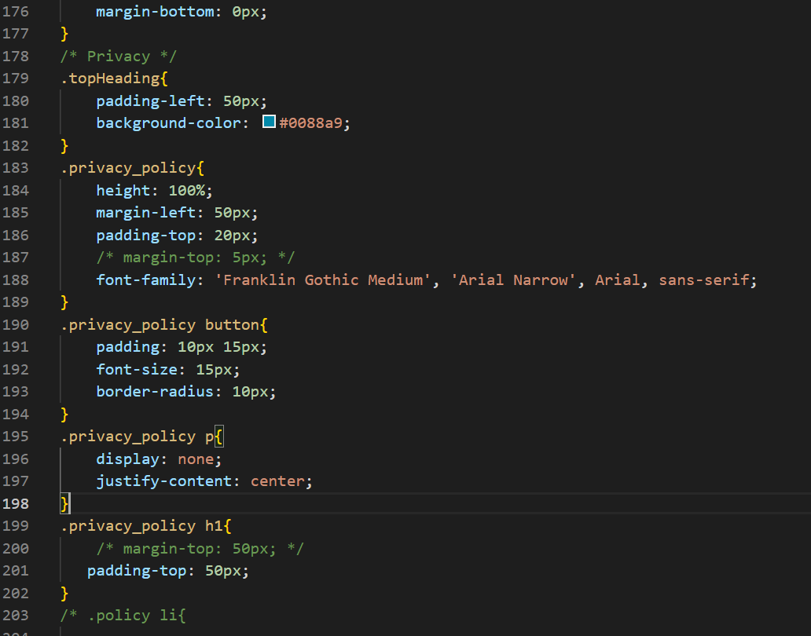

ABC Learning Center privacy center;

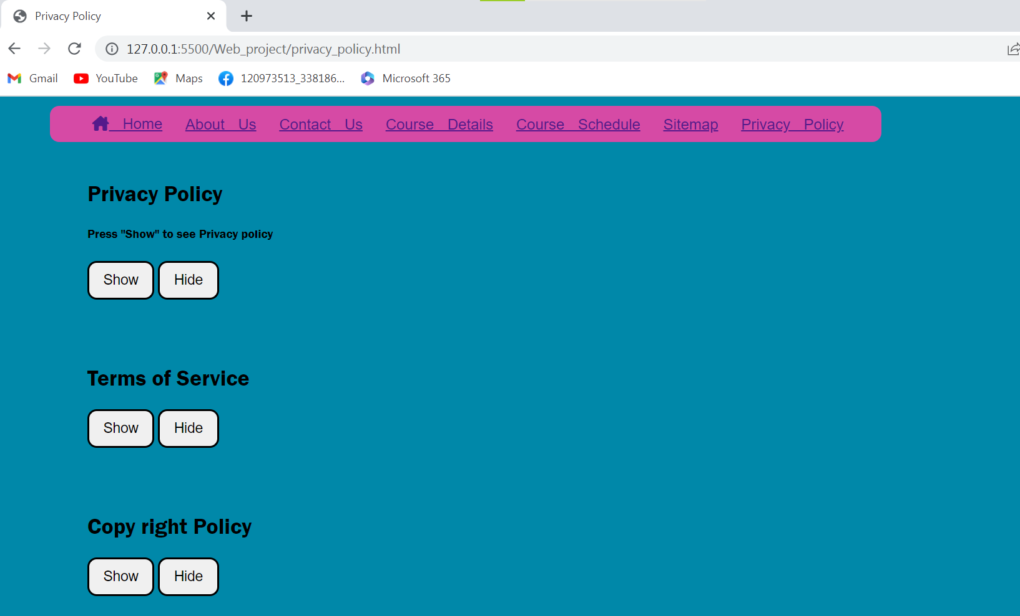

|  |  |  |  |  |
| --- | --- | --- | --- | --- |
| NO | Page | Purpose | Actual results | Pass/Fail |
| T01 | The Beginning | When the user  enter, show the alert box | Click the  “Ok” | Pass |
| T02 | Enter  The Website | When the user  click “Ok” | Going to the  website | Pass |
| T03 | ABC Learning First  page | When the user  Click “Home” | User can see  Home page | Pass |
| T04 | In the Home  Page | For filling  E-mail | User can  Be write e-mail | Pass |
| T05 | In the Home  Page | For filling  Password | User can  Be write Password | Pass |
| T06 | In the Home  Page | Click for  Login button | Login button  Can be click | Pass |
| T07 | For next page | Continue for  Next page | Next page can  Be arrived | Pass |
| T08 | Next Page | When user click  “About Us” on the navigation bar | “About Us” page can be display on the website | Pass |
| T09 | Website  “About us” page | When user  enter | Page information  Are showed | Pass |
| T10 | In the  “About Us “ page | When user point  First picture | First picture  Show hover  To the user | Pass |
| T11 | Also “About Us”  page | Second picture  When user point  out | Second picture  Show hover  To the user | Pass |
| T12 | In “About Us “  page | User want to see  More big | Third picture  Show more bigger  When point | Pass |
| T13 | “About Us” page | User can see  Other view of picture | Fourth picture  Produce hover effect | Pass |
| T14 | In the about  us Page | For read about  ABC center | User can clearly see paragraph | Pass |
| T15 | For next page | User To click  “Contact us”  page | User Can be  Click on the navication bar | Pass |
| T16 | Contact Us page | User click  “contact us” | User can be arrived to the next page | Pass |
| T17 | In the Contact us page | User to see center information | User can found clearly center information | Pass |
| T18 | About us page | When user  Arrived page want to know how contact | When arrive  User can be know  How contact the center | Pass |
| T19 | For Course Details  page | When user want to switch other page | Click and  Other page  Can be arrived | Pass |
| T20 | To the Course Detail page | Click on the  Course Detail  Page ,when user want to next page | User arrived to the  Course detail page | Pass |
| T21 | On the Course detail page | Course detail of ABC center  Want to see user | Course detail  Are described in  the page | Pass |
| T22 | Course Detail  page | Java course is shown in detail  And picture can be bigger | Hover effect  Can be used | Pass |
| T23 | Course Detail  page | Python programming  Course is show in detail | User can be see  clearly | Pass |
| T24 | Course Detail  page | Html,Css,Js to see for the user | User can be use  Hover effect | Pass |
| T23 | Course Detail  page | When user want to see  Next page | Course Schedule  Can be click on the navbar | Pass |
| T24 | Course Schedule  page | When user  Want to see schedule | Arrived to the  Course schedule page | Pass |
| T25 | Course Schedule  page | User who want to see clearly | Timetable  Hover effect can be use | Pass |
| T26 | Sitemap  page | When user click to the sitemap page | Arrived to the sitemap page | Pass |